EXPERIMENT 1
Create a Kanban Board to Visualize the Tasks.
1) Create Columns for To Do, In-Progress and Done.
2)Add Atleast 5 Sample Tasks
3) Move the Tasks across the Columns to Simulate the Workflow.

Aim

To create a Kanban Board in Jira Software, add sample tasks, and move them through different workflow stages to simulate software development.

Software Requirements
- Software: Jira Cloud (Web Application)
- Web Browser: Google Chrome or Microsoft Edge
- Internet Connection: Required

Theory

Jira is a project management tool used to track software development tasks. A Kanban Board displays work in different stages such as Backlog, Selected for Development, In Progress, and Done. It helps teams organize tasks, monitor progress, and improve collaboration.

Procedure

Step 1:

Open a web browser and visit Jira Cloud. Sign in with your account.
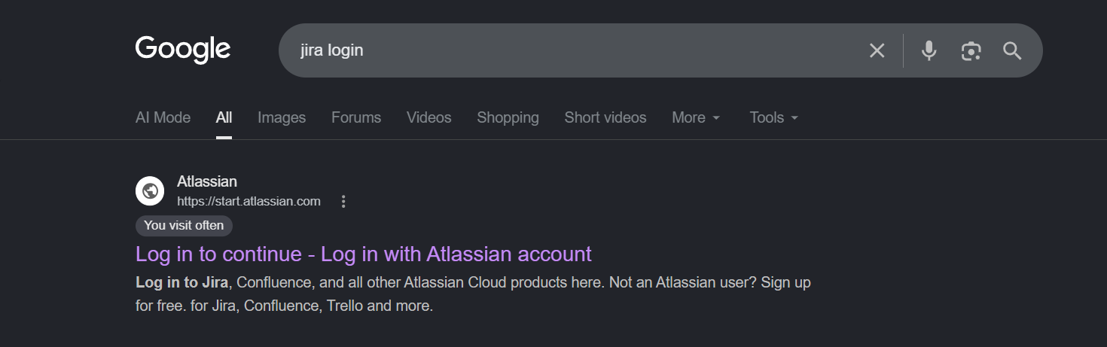

Step 2:

Open the Jira workspace from the left panel.

Step 3:

Click Create Space to create a new project.

Step 4:
Select Software Development as the category and choose the Kanban template. Click Next.
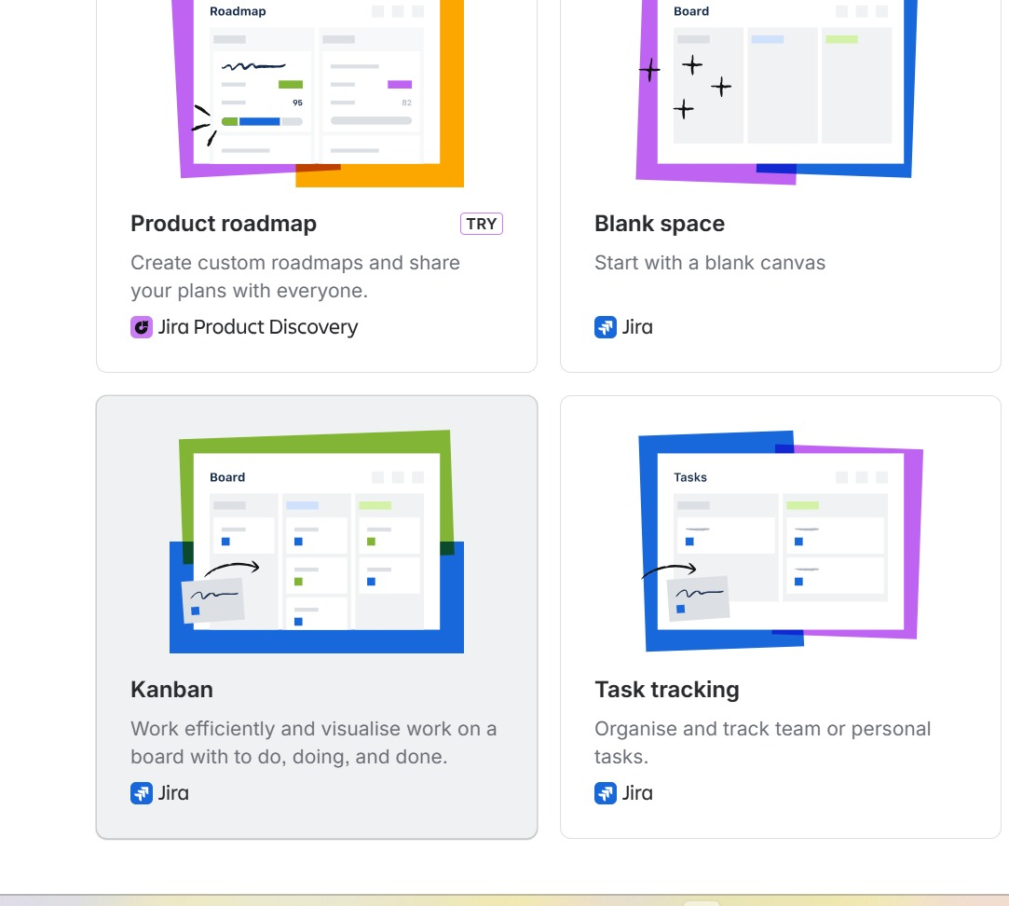
.

Step 5:

Enter the following details:
Choose Company-managed.
Enter:
- Project Name: JNM
Click Create Project.
Click Next.
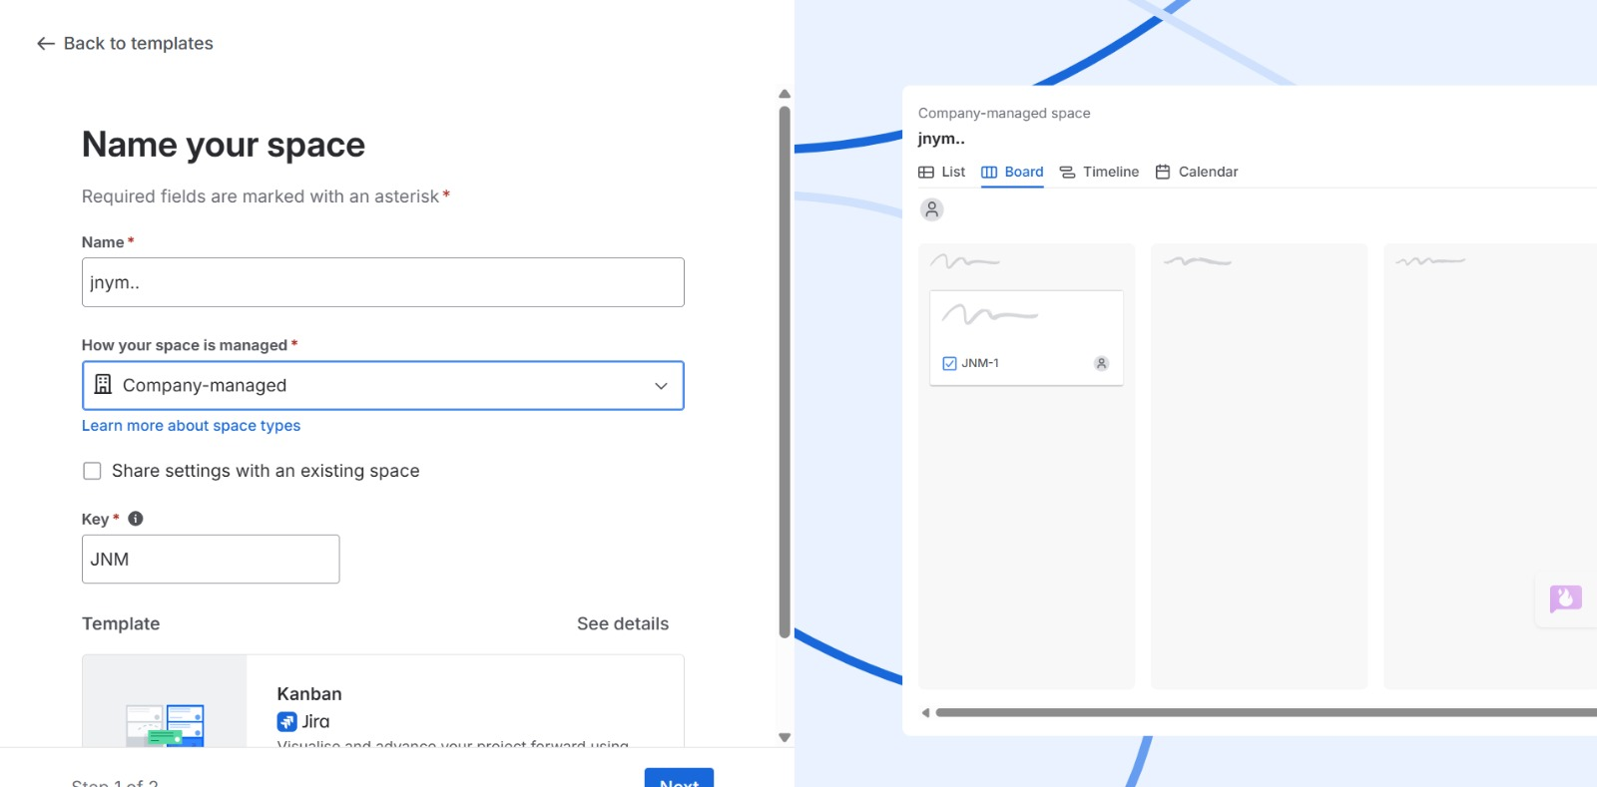
Figure 3. Entering Project Details.

Step 6: The Kanban Board is created with the workflow columns:
- Backlog
- Selected for Development
- In Progress
- Done
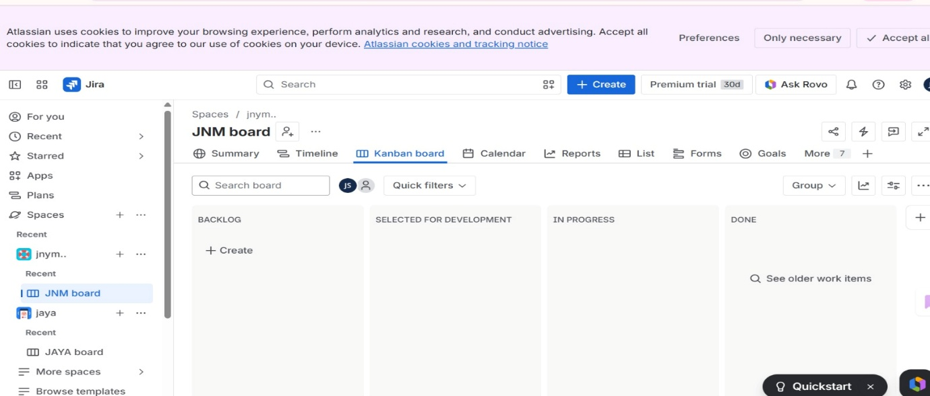

Step 7:

Add 5 Tasks
Click Create.

Task 1, Task 2, Task 3, Task 4, Task 5
Click Create.

Step 8:

View the Board
All five tasks will appear under To D

Step 9:

Move the Tasks
Drag and drop the cards.
Move:
To Do
To In Progress
To Done
According to the status of each tasks.
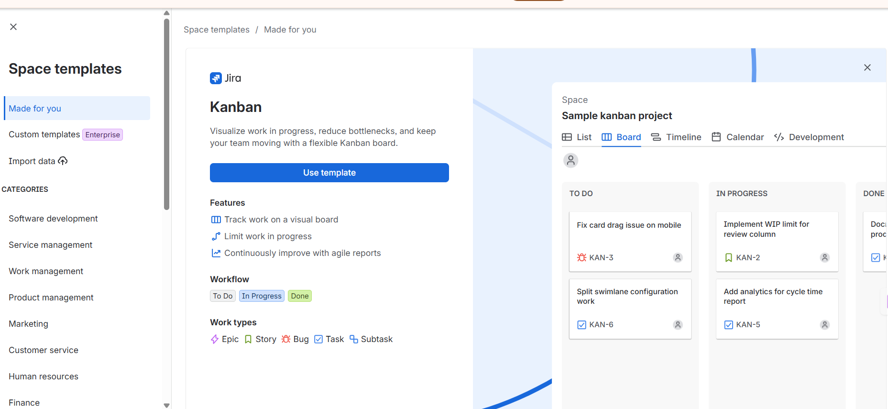

Result
The Kanban Board was successfully created in Jira Software. Sample tasks were added and moved through different workflow stages, demonstrating task tracking and project management using Kanban.

Using Trello
Step 1: Login
1. Open browser → go to trello.com
2. Login using Google / email account.
Step 2: Create a Board
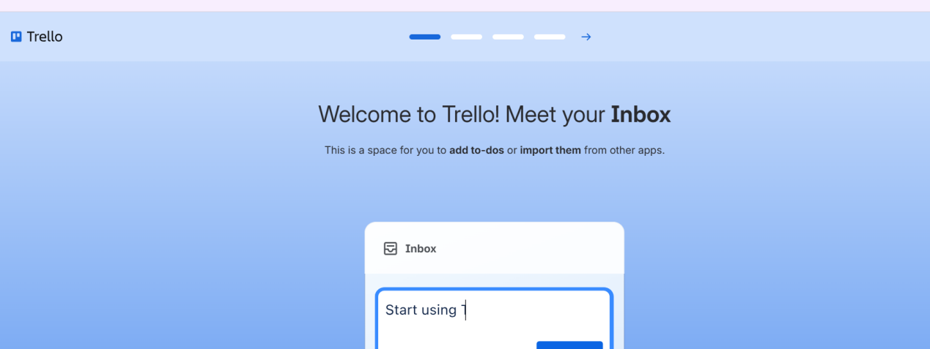

1. Click Create → Create Board
2. Name it: Kanban Workflow Board
3. Click Create.
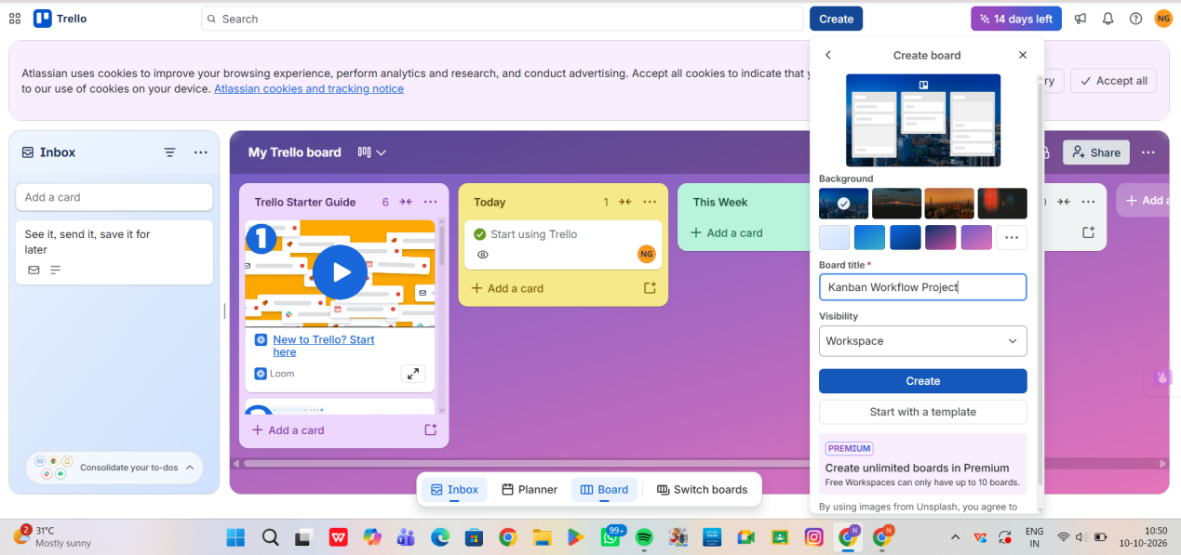
Step 3: Create Columns (Lists)
Rename default lists as:
• To Do
• In-Progress
• Done
(Delete extra lists if any.)
Step 4: Add Sample Tasks
Under To Do, add these 5 cards:
1. Collect project requirements
2. Design UI mockups
3. Develop login module
4. Test application
5. Prepare final report
Step 5: Move Tasks to In-Progress
Drag and drop:
• Collect project requirements
• Design UI mockups
➡ from To Do to In-Progress
Step 6: Move Completed Tasks to Done
After completion:
Drag Collect project requirements → to Done
Step 7: Continue Workflow Simulation
• Move Design UI mockups → Done
• Move Develop login module → In-Progress

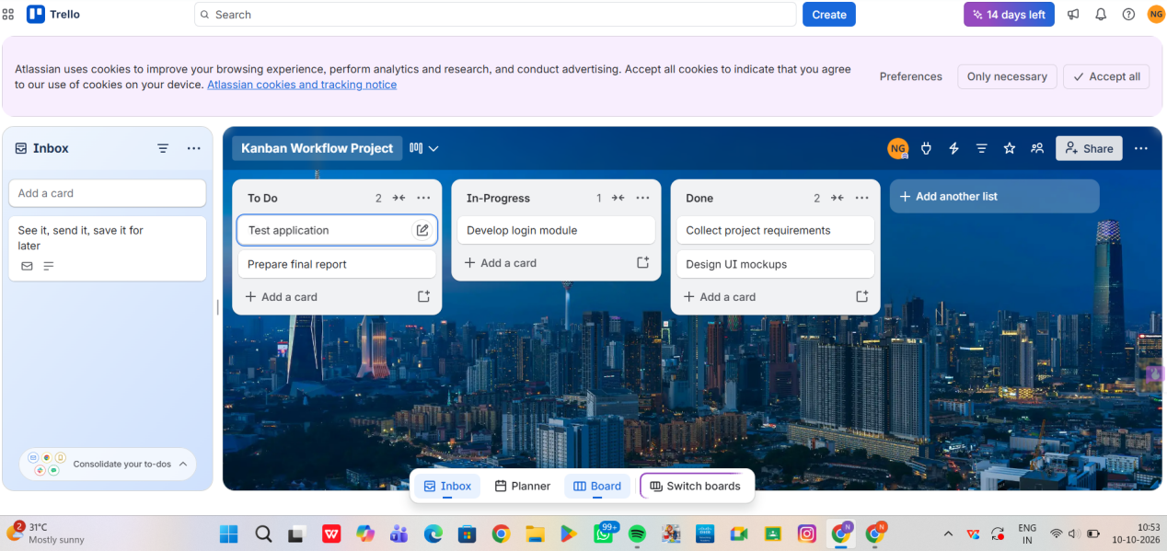
Result
Thus, a Kanban board was successfully created using Jira/Trello and tasks were moved
across columns to simulate workflow.
EXPERIMENT 2
Sketch a Simple Prototype of a Bus Ticket Booking System using
Figma Tool
Step 1: Login to Figma
1. Open browser → go to figma.com
2. Click Login / Sign Up
3. Login using Google or email.
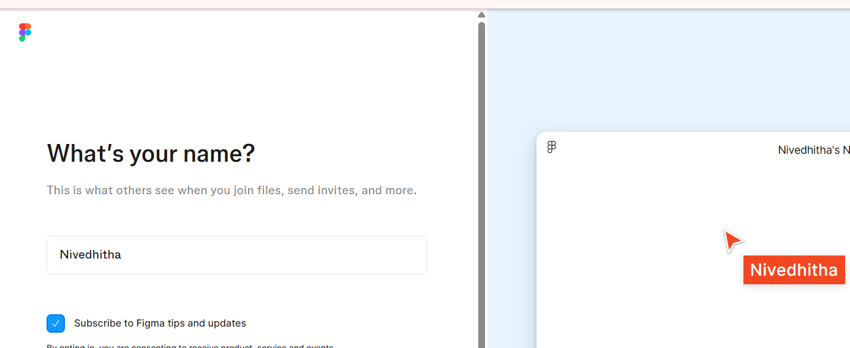
Step 2: Create a New Design File
1. Click New Design File
2. Rename file as:
Bus Ticket Booking Prototype
Step 3: Create Frame (Mobile Screen)
1. Click Frame Tool (F)
2. Select device: Android / iPhone (375 × 812)
3. This represents the mobile app screen.

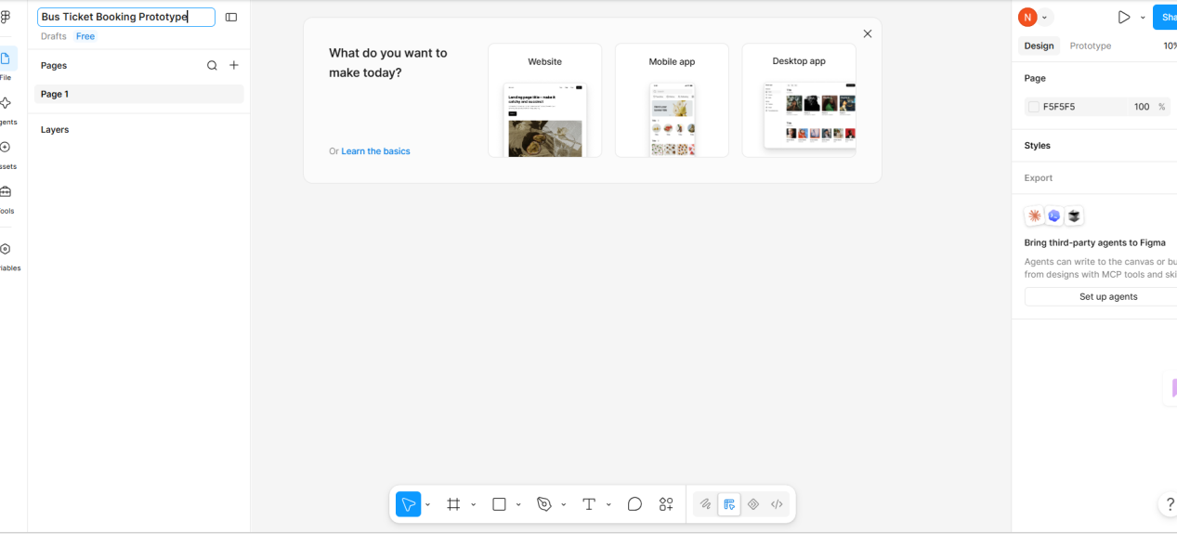Step 4: Design Home Screen
Add these UI elements:
Header
• Text: Bus Booking App
Input Fields
• From City
• To City
• Travel Date
Button
• Search Buses
Arrange neatly using rectangles and text.
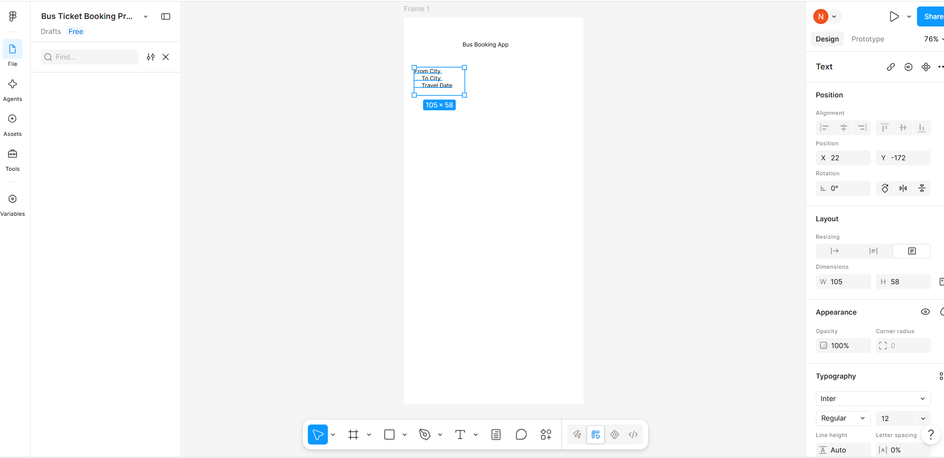

Step 5: Design Bus List Screen
1. Duplicate first frame (Ctrl + D)
2. Add:
• Bus Name
• Time
• Price
• Book Now button
Create 2–3 sample bus listings.
Step 7: Design Payment Screen
Duplicate frame:
Add:
• Ticket summary
• Total price
• Payment method dropdown
• Pay Now button
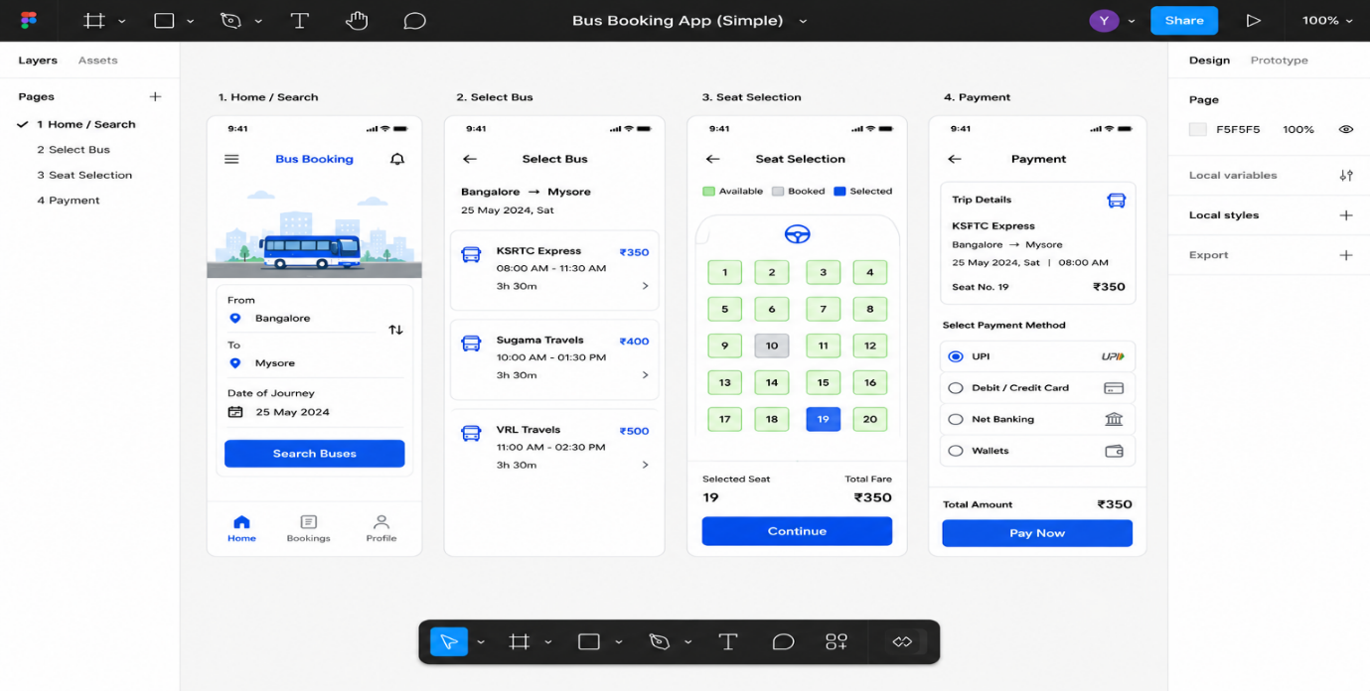

Result
Thus, a simple prototype of a Bus Ticket Booking System was successfully designed using Figma.

EXPERIMENT 3
The stakeholders have conflicting views on the user interface design
for an E-Commerce mobile app. Create a prototype using Figma tool
to discuss with the stakeholders to get their feedback and approval.
Step 1: Open figma.com, login, click New design file and rename it E-Commerce UI Prototype – Stakeholder Review.
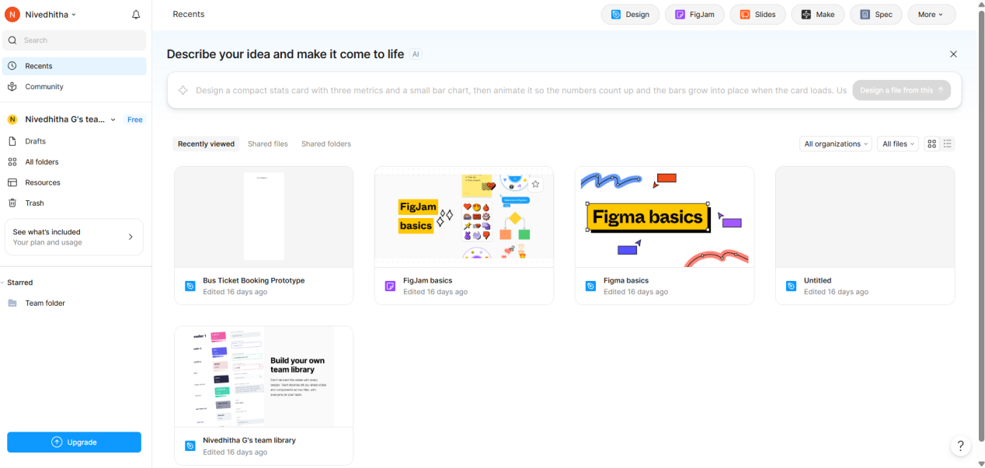
Step 2: Select the Frame Tool (F) and choose iPhone 14 (375 × 812).
Step 3: Design Home Screen – Version A (Minimal UI) with logo, search bar, banner, category icons, product cards and bottom navigation bar.
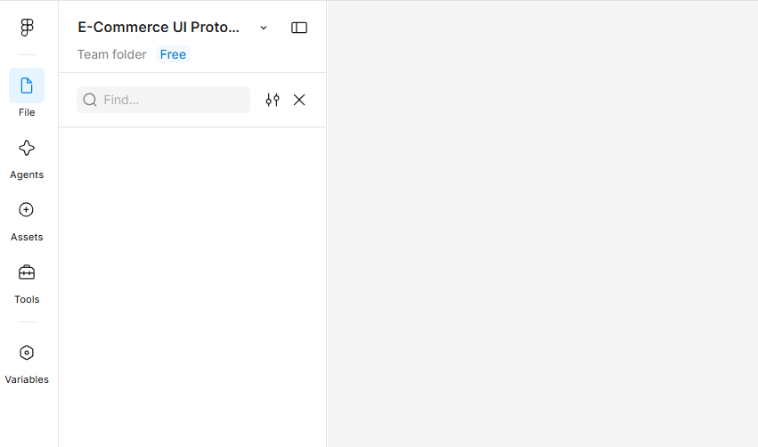
Step 4: Press Ctrl + D to duplicate it and make Home Screen – Version B (Visual UI) with a dark theme, larger banner, sidebar menu icon and bigger product cards.
Step 5: Duplicate frames to create the Product Detail, Cart, Payment and Order Confirmation screens with their elements.
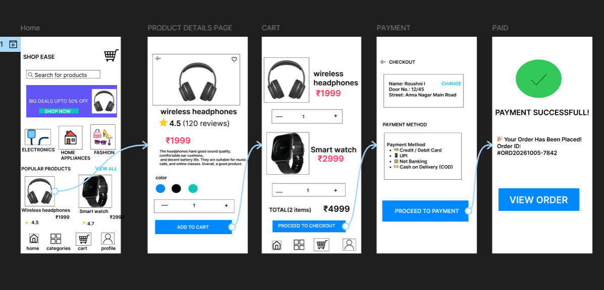
Step 6: In the Prototype tab, connect Home (A and B) → Product Detail → Cart → Payment → Order Confirmation, then click Play ▶ to test.
Step 7: Click Share → Anyone with link → Can comment, copy the link and send it to the stakeholders to collect feedback and approval.
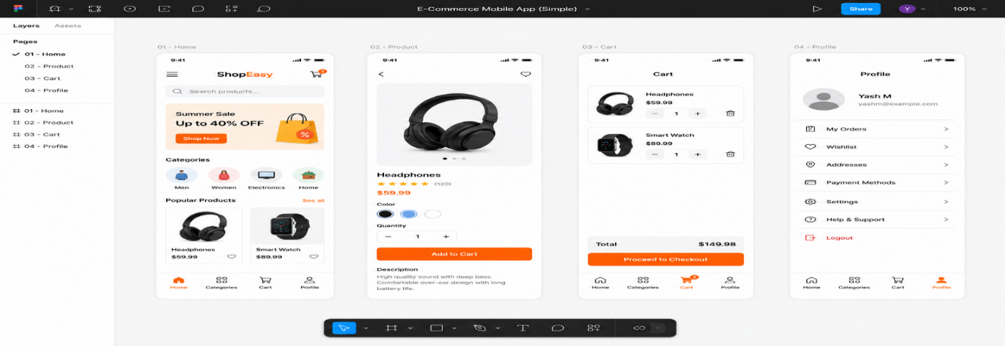
Result: A clickable Figma prototype with two home-screen options was created and shared, and stakeholder feedback was collected for approval.

EXPERIMENT 4
The string is a sequence of characters placed in double quotes (” “).
Performing different operations on string data is called String
Handling. Strings are immutable. Whenever a change to a String is made,
an entirely new String is created. If we want to store a group of
characters we can use a char array. String provides various methods to
perform different operations on strings. Using Raptor draw a flowchart
to display the total number of characters in the string and returns it.

Aim
The objective of this experiment is to create a flowchart using RAPTOR to accept a string as input, calculate the total number of characters in the string, and display the result.

Software Requirements

Software: RAPTOR Flowchart Software
Operating System: Windows 10/11
Hardware: PC/Laptop
Input Device: Keyboard
Theory
RAPTOR is a graphical programming tool used to design algorithms using flowcharts. It allows users to develop logic without writing programming code. In this experiment, a string is accepted as input, and the built-in LengthOf() function is used to determine the total number of characters present in the string. The result is then displayed on the screen. This experiment helps understand string manipulation and the use of predefined functions in RAPTOR.

Procedure

Step 1:
Open the RAPTOR application and create a new flowchart.

Step 2:
Insert an Input symbol and prompt the user to enter a string.

Step 3:
Insert an Assignment symbol and use the LengthOf() function to calculate the total number of characters in the entered string.

Step 4:
Insert an Output symbol to display the message "The total number of characters is" along with the calculated length.
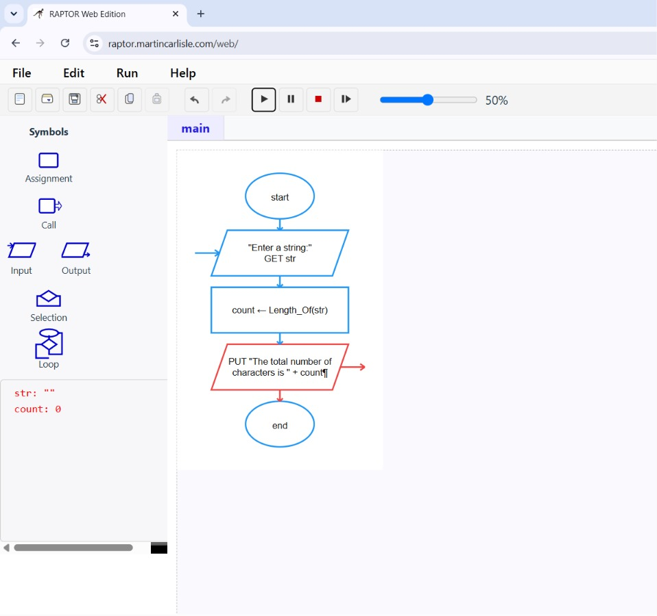
Figure 1. Displaying the Result.

Step 5:
Run the flowchart, enter different strings, and verify that the output displays the correct number of characters.
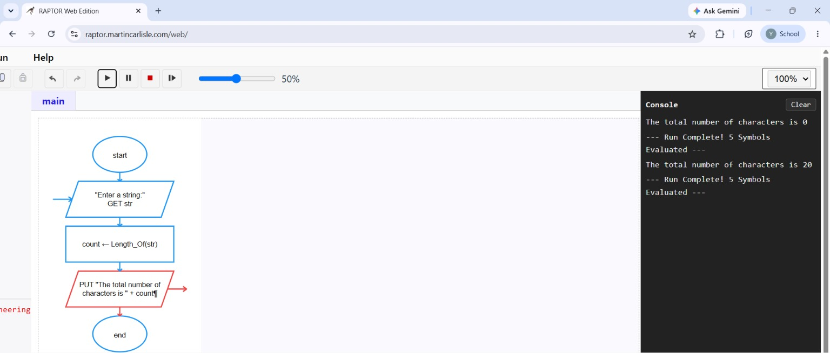
Figure 2. Executing the Flowchart.

Result
The flowchart was successfully created using RAPTOR to calculate the total number of characters in a given string. The program correctly accepted the input string, computed its length using the LengthOf() function, and displayed the result. The experiment demonstrated the use of string functions and flowchart-based programming for solving simple string-processing problems.

EXPERIMENT 5
Using Raptor – Draw and validate a flowchart for a given string of lower
case English alphabets. One can choose any two characters in the string
and replace all the occurrences of the first character with the second
character and replace all the occurrences of the second character with
the first character. Using Raptor draw and validate the flowchart
lexicographically smallest string that can be obtained by doing this
operation at most once.
Aim
The objective of this experiment is to draw and validate a flowchart in RAPTOR that accepts a string of lowercase English alphabets and generates the lexicographically smallest string by swapping all occurrences of two selected characters at most once.

Software Requirements
Software: RAPTOR Flowchart Software
Operating System: Windows 10/11
Hardware: PC/Laptop
Input Device: Keyboard

Theory
RAPTOR is a flowchart-based programming environment used to design and test algorithms visually. In this experiment, a string containing only lowercase English letters is provided as input. The algorithm identifies two characters whose complete interchange results in the lexicographically smallest possible string. The operation can be performed only once, where every occurrence of the first selected character is replaced with the second character and vice versa. This experiment demonstrates string manipulation, character replacement, and optimization techniques using flowchart programming.

Procedure

Step 1:
Open the RAPTOR application and create a new flowchart.

Step 2:
Insert an Input symbol to accept a string containing lowercase English alphabets.

Step 3:
Use assignment and decision symbols to compare the characters in the string and identify the pair of characters whose interchange produces the
lexicographical order.
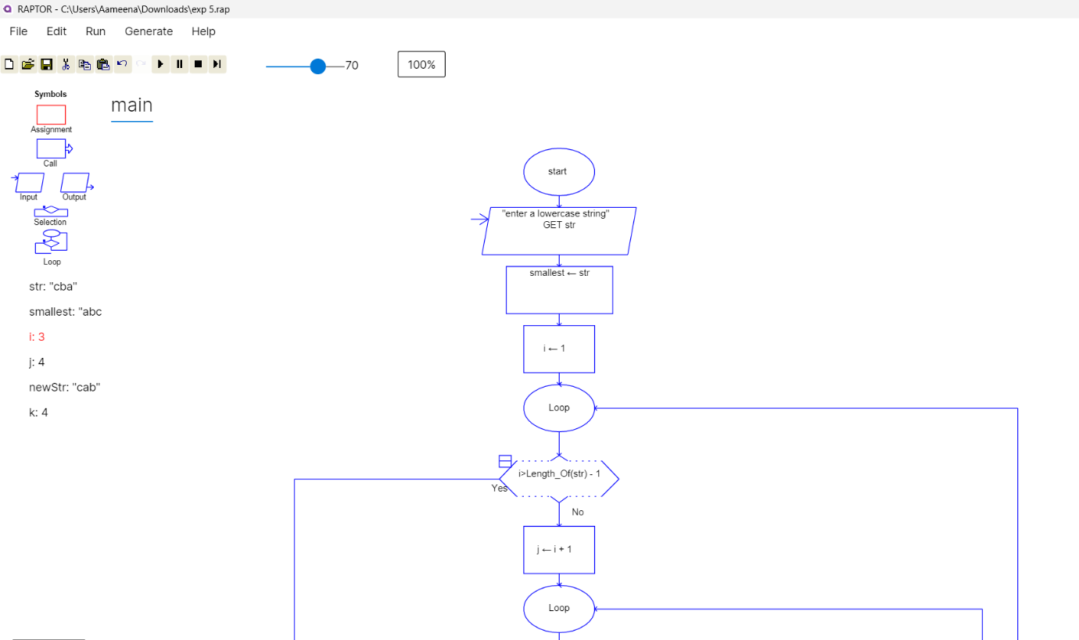

Step 4:
Replace every occurrence of the first selected character with the second character and replace every occurrence of the second character with the first character. Ensure that this replacement is performed only once.

Step 5:
Store the modified string and display it using an Output symbol.

Step 6:
Execute the flowchart with different input strings and verify that the generated string is the lexicographically smallest possible after performing at most one swap.
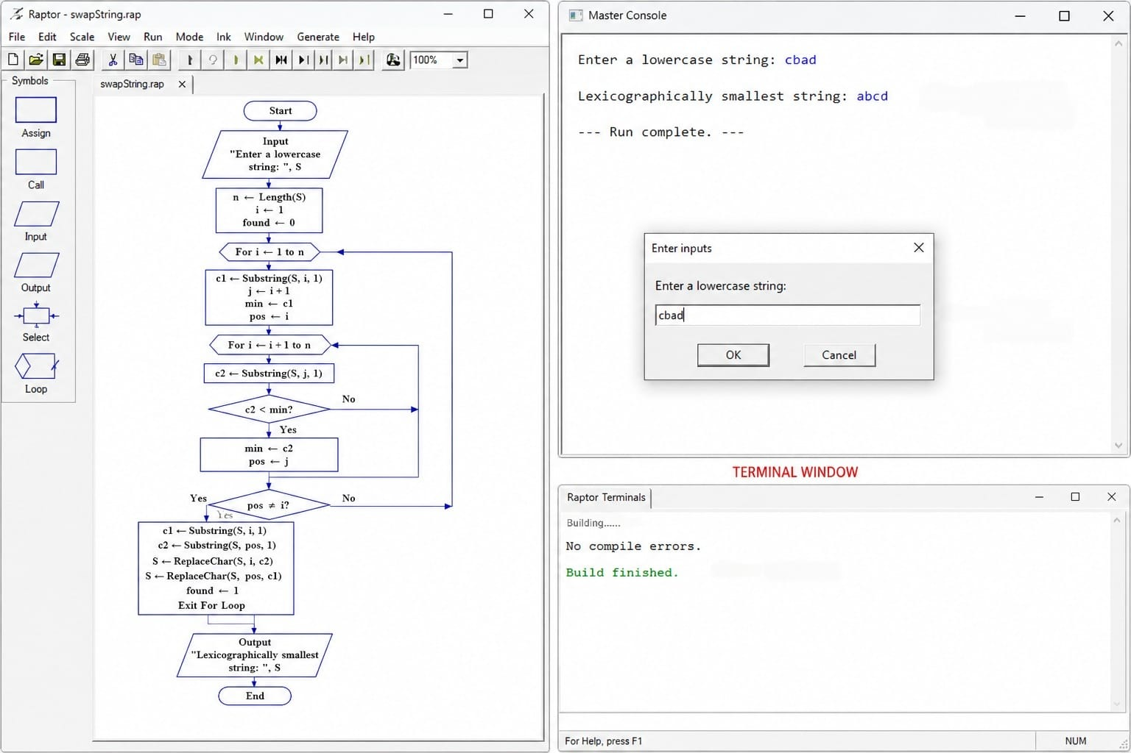
Figure 1. Execution of the Flowchart.

Result
The flowchart was successfully designed and validated using RAPTOR to generate the lexicographically smallest string by swapping all occurrences of two selected characters at most once. The experiment demonstrated the use of decision-making, string processing, character replacement, and optimization techniques through flowchart-based programming.

